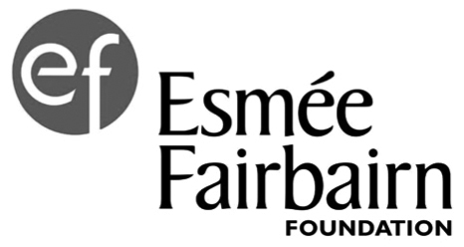
Funding Progress Report

We use progress reports to find out how the work we are funding is going and understand how it's making progress towards our impact goals. You can read more about our approach on our website https://esmeefairbairn.org.uk/our-support/grants/reporting/

To ensure that reporting is simple for you and useful to both of us, we will only ask for information we need and use. You don’t need to use this reporting template - you can submit a report you’re already producing.
This could be an Impact Report, a report for your trustee board, a progress report you’ve written for another funder, or your Annual Report. If you don’t have one of these, you can use this report template.

We like reports to be brief – no more than 500 words per section. Base your report on the past year’s progress towards the (up to) three key outcomes you aimed to bring about over the term of our funding. For final reports, it would be good if you could reflect on progress over the whole funding period.

We want to emphasise that we are genuinely interested in knowing when things didn’t work out according to plan. How did you learn from this experience and use the knowledge to move forward?

This is not your only opportunity to talk to us! Please keep your Grants Manager up-to-date with any significant news, changes to how you want to use the grant, or changes of key staff.

- External context – summarise any major changes which have affected your progress towards your outcomes.

- Internal context – are there any major issues which have affected your progress towards your outcomes?

- First key outcome: Please see your report email for a reminder
Evidence of progress to date.

What has not gone to plan?

What changes have you made as a result of what you’ve learned?

- Second key outcome: Please see your report email for a reminder
Evidence of progress to date.

What has not gone to plan?

What changes have you made as a result of what you’ve learned?

- Third key outcome: Please see your report email for a reminder
Evidence of progress to date.

What has not gone to plan?

What changes have you made as a result of what you’ve learned?

- Is there anything else you would like to tell us or ask us?
Include any conditions of the grant now met, significant changes to future plans, or funding.

In addition, please attach
- A breakdown of income and expenditure for the past year’s funded work against your original budget. If this differs from your original income and expenditure budget please explain why.
If our grant was for core costs, send your management accounts covering the last 12 months.
- An income and expenditure budget for the year ahead, with secured income clearly highlighted.
- A copy of your latest annual report and full accounts covering the last 12 months (if you have not already sent them). If not yet available, please send them as soon as they are.

How do I report?
Two months before each progress report is due, you will be emailed a personalised link to our online progress reporting system. If you haven’t received your link, please contact funding@esmeefairbairn.org.uk

